# **Task 1:**

# SELECT * FROM REGION WHERE LOCAL_AUTHORITY_CODE_ <> LOCAL_AUTHORITY_CODE_2;

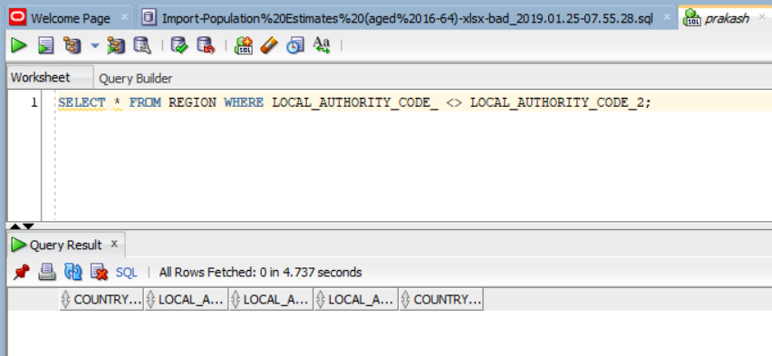

# **Task 2:**

# SELECT * FROM REGION WHERE LOCAL_AUTHORITY_CODE <> LOCAL_AUTHORITY_CODE_2;



# **Task 3:**

# SELECT * FROM REGION WHERE COUNTRY_NAME <> COUNTRY_NAME2;

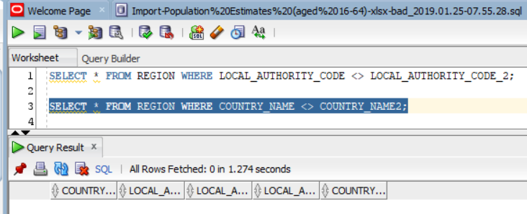

# **Task 4:**

Dropping Redundant table.

1. ALTER TABLE REGION DROP COLUMN LOCAL_AUTHORITY_CODE_2;

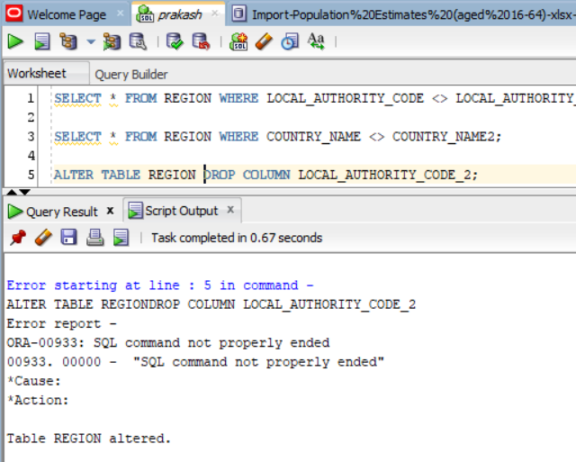

# ALTER TABLE REGION DROP COLUMN COUNTRY_NAME2;

# 

# Task 4: Creating Pivot table.

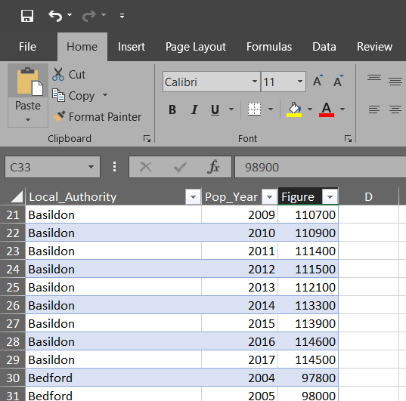

# Task 5: Finding Average of data.

1. SELECT POP_YEAR, ROUND(AVG(FIGURE),2) AS AVG_POP FROM POPULATION GROUP BY POP_YEAR ORDER BY POP_YEAR;

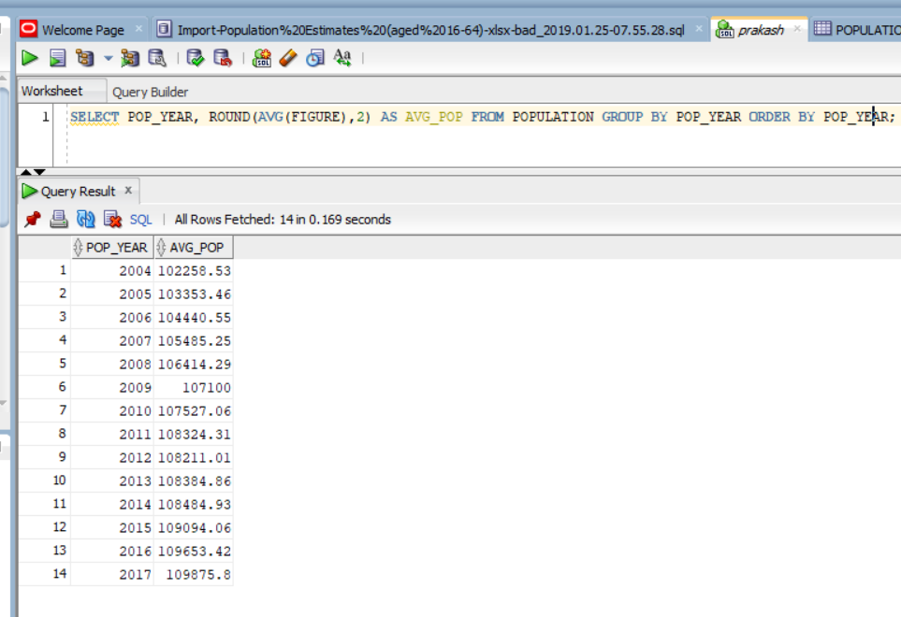

Or it can be achieved from authority.

1. SELECT LOCAL_AUTHORITY, ROUND(AVG(FIGURE),2) AS AVG_POP FROM POPULATION GROUP BY LOCAL_AUTHORITY ORDER BY LOCAL_AUTHORITY;

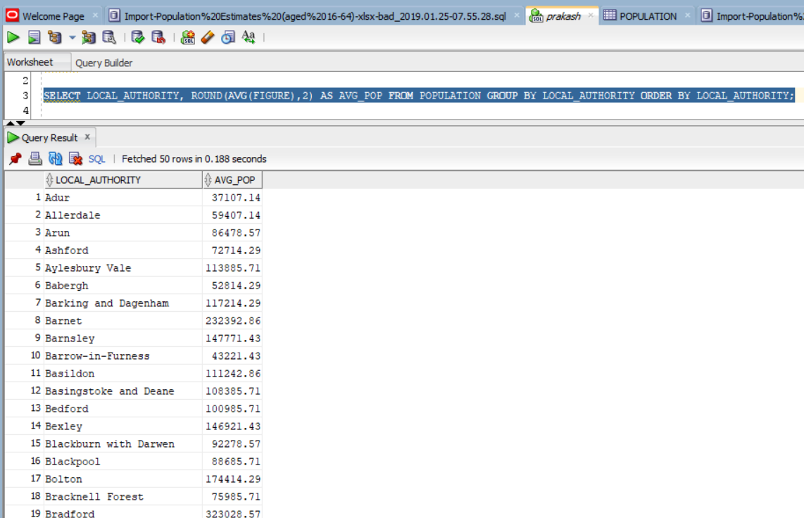

# Task 6: Trying to Select deleted column.

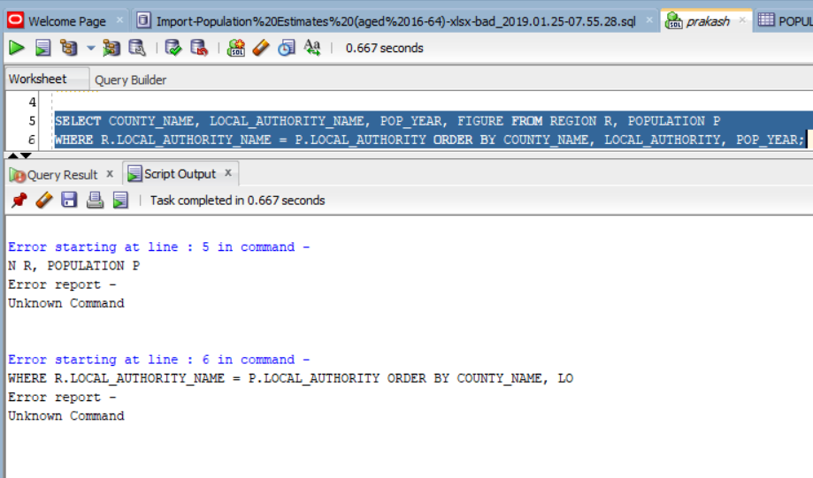

# Task 7: OLAP (On-Line Analytical Processing)

1. Roll Up Example

SELECT COUNTRY_NAME, LOCAL_AUTHORITY_NAME, ROUND(AVG(FIGURE),2) AS POP_FIG

FROM REGION R, POPULATION P

WHERE R.LOCAL_AUTHORITY_NAME = P.LOCAL_AUTHORITY

GROUP BY ROLLUP(COUNTRY_NAME, LOCAL_AUTHORITY_NAME)

ORDER BY COUNTRY_NAME;

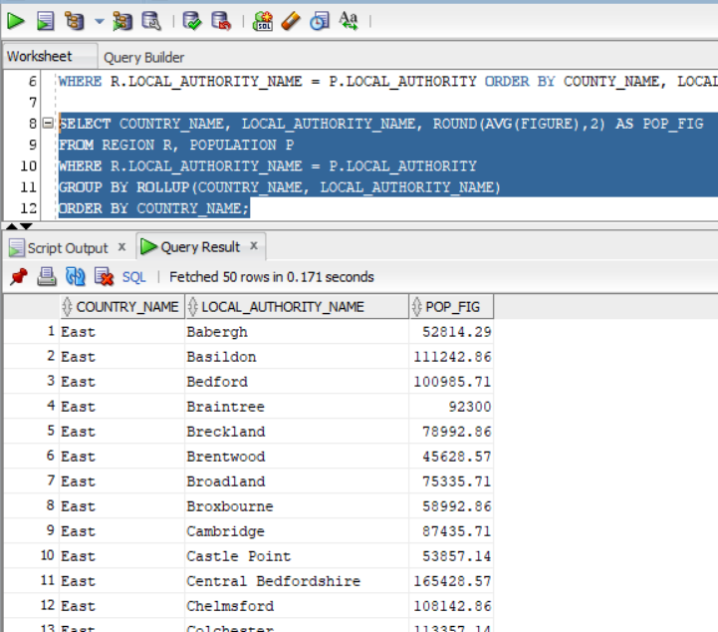

1. Cube

SELECT COUNTRY_NAME, LOCAL_AUTHORITY_NAME, ROUND(AVG(FIGURE),2) AS POP_FIG

FROM REGION R, POPULATION P

WHERE R.LOCAL_AUTHORITY_NAME = P.LOCAL_AUTHORITY

GROUP BY CUBE(COUNTRY_NAME, LOCAL_AUTHORITY_NAME)

ORDER BY COUNTRY_NAME;

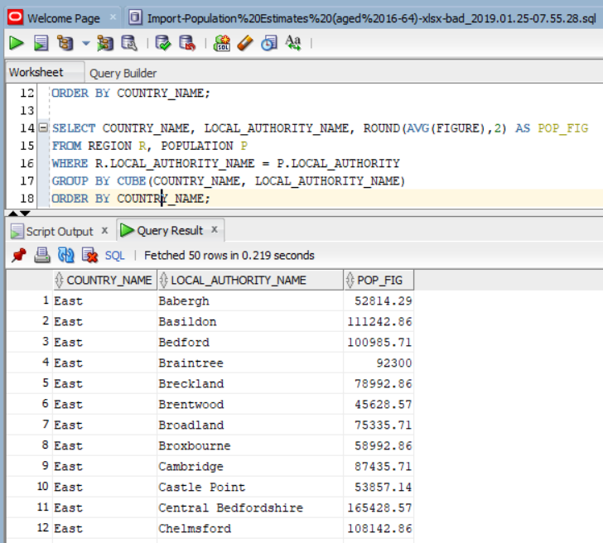

# Task 8: Missing data.

1. Checking Authority

SELECT LOCAL_AUTHORITY

FROM POPULATION

WHERE LOCAL_AUTHORITY NOT IN

(SELECT LOCAL_AUTHORITY_NAME FROM REGION);

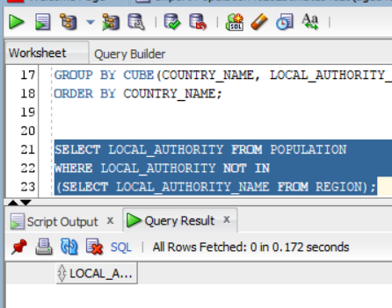

No result is obtained. There might be something wrong while importing. So checking with

1. Checking Authority

SELECT LOCAL_AUTHORITY

FROM POPULATION

WHERE LOCAL_AUTHORITY NOT IN

(SELECT LOCAL_AUTHORITY_NAME FROM REGION);

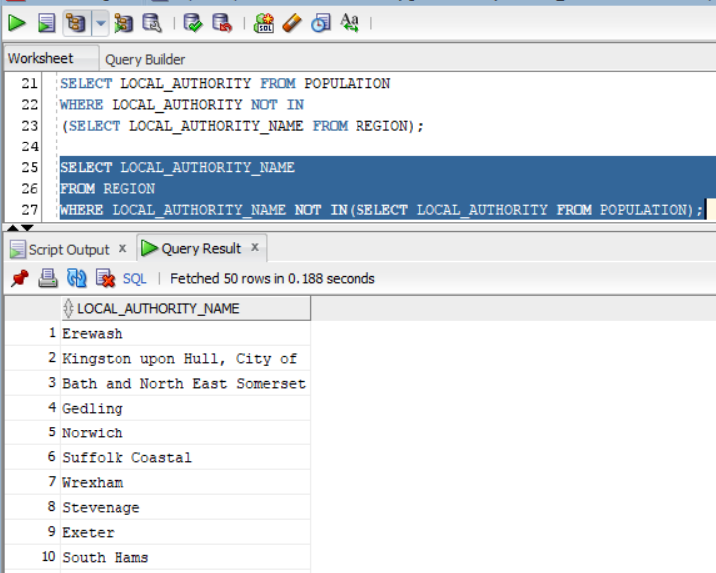

Further investigation gave one area.

1. Further investigation

SELECT LOCAL_AUTHORITY_NAME, COUNTY_NAME

FROM REGION

WHERE LOCAL_AUTHORITY_NAME NOT IN

(SELECT LOCAL_AUTHORITY FROM POPULATION);

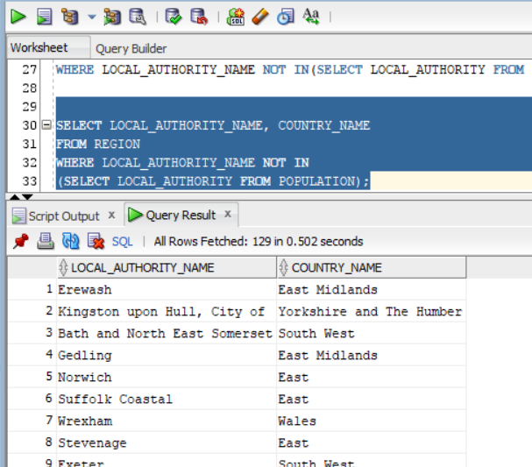

Welsh data were missing from the dataset.

# Task 9: Missing Values.